Special parts for customers made even faster: igus triples its 3D printing service
New laser sintering printers expand the 3D printing capacity for the production of durable wear-resistant parts

The demand for customised special solutions is steadily increasing, especially for the motion plastics specialist igus. Increasingly more customers are turning to the fast 3D printing service for long-lasting wear-resistant parts made of high-performance plastics. Whether for short-term spare parts procurement, for prototype construction or for the production of lubrication-free small batches. To meet this demand, the Cologne plastics specialist has now tripled its 3D laser sintering printing capacity.

If the user wants to produce an abrasion-resistant special part or a small batch then igus has the right solution with the 3D printing service. Call up www.igus.in/3D-printservice, upload CAD data, select material and activate order. In this way the user – from hobbyists to major industrial customers – can quickly obtain igus's wear-resistant special solution. Most of the components are manufactured using the laser sintering process. In this process, the abrasion-resistant laser sintering material iglidur I3, specially developed by motion plastics specialist igus, is applied on the entire working platform and sintered with a laser. After each work step, the plate is lowered and a new layer applied. "Due to the very high demand for wear-resistant special solutions through the 3D printing service, we have now tripled our capacities with new laser sintering printers," explains Tom Krause, Head of Additive Manufacturing at igus.

Quickly printed complex components
The advantages of the laser sintering process are obvious. The laser sintering printers can produce simple and complex types as well as mobile solutions. "In an installation space of 220x170x300 millimetres, for example, 5,000 plain bearings with an inner diameter of 10 millimetres can be produced per laser sintering system within 30 hours. Laser sintering ensures that we can offer the components not only fast, but also with a higher strength and more cost-effectively than the FDM process," notes Tom Krause. High costs, such as the production of injection moulding tools, are eliminated and possible design changes can easily be made on the computer, whereas in conventional injection moulding, entire moulds need to be changed. In addition, there is no price difference between complex and simple shapes. If the customer wishes to have wear-resistant gears made, he can use the abrasion-resistant laser sintering material iglidur I6, which was specially developed for gears, in the 3D printing service. If a series with up to 4,000 parts have to be printed, injection moulding tools can also be produced in additive manufacturing, which are later used in the injection moulding machine. The advantage here is that the user can freely select the suitable material from more than 50 iglidur materials.

Caption:
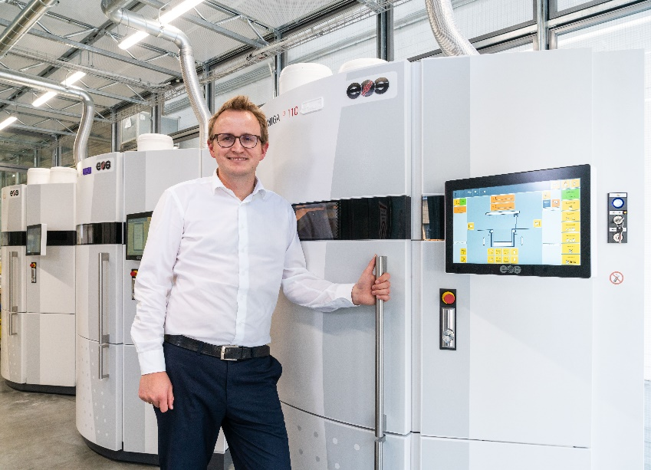
Picture PM5918-1
"Due to the high demand, we are further expanding our 3D printing service for wear-resistant special solutions with new laser sintering printers," says Tom Krause, Business Division Manager Additive Manufacturing at igus. (Source: igus GmbH)

PRESS CONTACT:  Shery George  igus (India) Private Limited  36/1, Sy. No. 17/3  Euro School Road,  Dodda Nekkundi Industrial Area - 2nd Stage  Mahadevapura Post  Bangalore - 560048  Phone : +91-80-45127827 (Direct)  Cell : +91-9379517885  sgeorge@igus.in  Visit us on www.igus.in | ABOUT IGUS:  igus GmbH is a globally leading manufacturer of energy chain systems and polymer plain bearings. The Cologne-based family business has offices in 35 countries and employs around 3,800 people around the world. In 2017, igus generated a turnover of 690 million euros with motion plastics, plastic components for moving applications. igus operates the largest test laboratories and factories in its sector to offer customers quick turnaround times on innovative products and solutions tailored to their needs.

The terms "igus", “Apiro”, "chainflex", "CFRIP", "conprotect", "CTD", "drylin", "dry-tech", "dryspin", "easy chain", "e-chain", "e-chain-systems", "e-ketten", "e-kettensysteme", "e-skin", "flizz", “igear”, "iglidur", "igubal", “kineKIT”, "manus", "motion plastics", "pikchain", "plastics for longer life", "readychain", "readycable", “ReBeL”, "speedigus", "triflex", "robolink", and "xiros" are protected by trademark laws in the Federal Republic of Germany and internationally, where applicable.

