World premiere RBTX: online platform brings robotics users and suppliers together
Quick and easy Low Cost Automation

RBTX.com is the new platform that brings together users and suppliers of low-cost robotics components quickly and easily. Users can put together a low-cost robotics solution that matches their requirements and budget. Suppliers of robotics components are able to present their products to a larger public in a new marketplace.

The goal of RBTX.com is to combine all the possibilities of low-cost robotics on one platform and make everything transparent and easy. In conjunction with 16 other industrial partners taking part in Hannover Messe, igus will be presenting the world's first model of a platform that brings suppliers and users together online. The idea: to enable customers to solve their own robot solution with just a few clicks of the mouse. The basic electro-mechanical structure is the starting point for a "rohbot" from igus, such robots including articulated-arm robots, delta robots and Cartesian robots. In the next step, the user supplements this basic structure by adding individual components of different manufacturers such as grippers, cameras and control systems. The advantage of this is the certainty that the components are compatible with each other.

Suppliers reach new target groups
The purpose of the online platform is to enable manufacturers to open up new sales channels for their low-cost automation products and reach new target groups, new components can be added to the platform continually. In future, users will always have up-to-date and clear access to a rapidly developing market segment. "The RBTX.com concept intended for companies, start-ups, research institutes and mechanical engineering companies offers fast, customised robot solutions at low starting costs of just a few thousand euros and with short amortisation times", explains Christian Batz, Head of igus digITal. "What we are talking about here is a low-risk way of entering the era of automation and investing in the competitiveness of tomorrow." In future, the platform is also intended to enable configuration of the robot mechanics, beginning with gearboxes, joints and connecting parts.

Digital twin: the real and digital worlds of robotics come together
At the trade fair stand in Hanover, augmented reality (AR) can be used to simulate the digital twin of a robot in a fictional production environment, including all of the robot's movements. This provides visitors with an interesting look into a possible future of the platform, whereby an AR tool makes the entire robot package visible. In this way, the customer can observe the robot in its robot cell as well as its range of reach and its movements, and can do so on site directly at the machine, where adaptations can also be made if necessary. "The user can watch the interplay of reality and digital robot on a tablet. And the user also finds out whether the configuration works and whether it is suitable for the place where it is to be used", says Christian Batz. "This vision of RBTX.com shows how users directly profit from the combination of low-cost automation and digitalisation."

PRESS CONTACT:  Shery George  igus (India) Private Limited  36/1, Sy. No. 17/3  Euro School Road,  Dodda Nekkundi Industrial Area - 2nd Stage  Mahadevapura Post  Bangalore - 560048  Phone : +91-80-45127827 (Direct)  Cell : +91-9379517885  sgeorge@igus.in  Visit us on www.igus.in | ABOUT IGUS:  igus GmbH is a globally leading manufacturer of energy chain systems and polymer plain bearings. The Cologne-based family business has offices in 35 countries and employs around 4,150 people around the world. In 2018, igus generated a turnover of 748 million euros with motion plastics, plastic components for moving applications. igus operates the largest test laboratories and factories in its sector to offer customers quick turnaround times on innovative products and solutions tailored to their needs.

The terms "igus", “Apiro”, "chainflex", "CFRIP", "conprotect", "CTD", "drylin", "dry-tech", "dryspin", "easy chain", "e-chain", "e-chain-systems", "e-ketten", "e-kettensysteme", "e-skin", "flizz", “igear”, "iglidur", "igubal", “kineKIT”, "manus", "motion plastics", "pikchain", "plastics for longer life", "readychain", "readycable", “ReBeL”, "speedigus", "triflex", "robolink", and "xiros" are protected by trademark laws in the Federal Republic of Germany and internationally, where applicable.

Image captions:


Picture PM2219-1
At Hannover Messe, igus will be presenting a world premiere: RBTX, a platform that brings suppliers and users of low-cost robotics together.
(Source: igus GmbH)

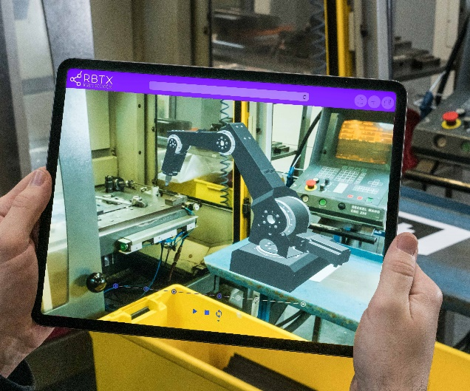
Picture PM2219-2
Together with visitors, igus will be venturing a look into the future by utilising an augmented reality tool that enables use of a digital twin to be simulated directly at the machine. (Source: igus GmbH)

